Container Based Cross-cloud Horizon VDI
Jianming Fan, Tracy Chi, Chunyan Ji, Luke Yue, Zhimin LI, Yanzhao Zhang
{jianmingf, chit, cji, lukey, zhiminl, yanzhaoz}@vmware.com

Abstract
Summarize what you do in this paper

Keywords
Horizon VDI, Cross-cloud, Container, Docker swarm, Redis, Micro service, Migration

Introduction
There are many popular cloud vendors either provide service globally like Google cloud platform, Amazon AWS, Microsoft Azure or provide service locally like Alibaba Cloud, Qingcloud. More and more enterprises are planning to run their core business by public cloud service, one of the important services is virtual Desktop service, e.g. Horizon Air by VMware, Workspace by Amazon AWS, VDI by Microsoft Azure. “The fact that most CIOs leverage multiple cloud providers means enterprises are already waist-deep in complex cloud vendor management” [2]. Each of the cloud vendors has different strength and weakness in cost, placement, performance, SLA, functionality, security, and compliance. Considering the diversity and heterogeneity of cloud service, company would like to choose different clouds overtime that meet its requirements. For instance, company may choose to deploy VDI on different public clouds due to less network latency, cost effective or data protection policy in different geography. As a result, company are left with multiple VDI systems in different clouds that are isolated from each other. However, the enterprises have to solve the problems, including complexity in management, higher cost, security vulnerability and data isolation between clouds.
Facing the above benefits and problems, it would be promising if we can deploy VDI on multiple clouds and migrate freely between clouds according to customers’ ever changing requirement. Container based cross-cloud Horizon VDI aims to enable enterprise to run, manage, migrate and secure virtual desktops cross cloud using unified software interface and allow end user from anywhere to access desktop on cloud with the lowest latency.
There are several challenges we need to consider. First, the traditional VDI desktop manager is tightly coupled and large in size, making it hard to migrate efficiently cross clouds with limited bandwidth. Second, it presents a real challenge to leverage existing technology to migrate and load balance service cross cloud effectively, and to adapt VDI to it during design so that the whole system runs seamlessly.

Third, network connectivity is affected by mixed factors. Different cloud vendors provide different network solution that may be incompatible; And application framework may have unique requirement on the network connectivity. Last but not the least, as the network latency cross cloud becomes much higher, it is critical to optimize the latency on communication path so that we can present remote desktop fluently to end user.
To address these issues, we design an innovative container based cross cloud VDI solution. With this new design, the VDI desktop manager is divided into several lightweight micro services which communicate with each other using RESTful API. Micro services are shipped into containers, managed by container orchestration tools. We leverage container orchestration tools to auto scale, load balance and migrate services cross cloud. In this paper, we choose docker swarm as the orchestration tool to prove our concept. Docker swarm overlay network is quiet new software, released several months ago, and doesn’t take cross cloud network into consideration. To make it happen, we do special configuration with the network connectivity. We also design a distributed data store tailored for the desktop manager to reduce the latency.
Desktops are created from desktop template, that is windows or Linux os image shipped with VDI agent software. We already install such desktop template on Qingcloud, Google cloud platform, and Amazon AWS. Desktops are designed to be floating cross cloud. The goal is to deliver desktop of low latency from any cloud instantly to user when login, then recycle it to reduce cost when user logoff.
The main advantages of the system are as follows. Enterprises enjoy the freedom to run their desktops on any cloud without complexity in management and data isolation. Using this approach, various concerns on clouds are addressed, like reduce cost, protect privacy, meet compliance, or improve dependability. End users enjoy reliable desktop service with lower latency whether in office or on travel.
The remaining section xxxxx…

Related work
VMware Cross-Cloud Architecture™ provides an easy way to run, manage, connect and secure apps across multiple clouds and devices in a common operating environment. It consists of several components, like VMware Cloud Foundation, VMware cross-cloud services which are still under development and vRealize Cloud Management. Basically, VMware cross-cloud strategy mainly focus on SDDC level, and is more concerned with providing a general platform cross cloud upon which application can run, connect, deploy, without even knowing which cloud it is running on.
Cross cloud VDI bears similar vision with VMware cross cloud strategy, but different significantly in the implementation. Cross cloud VDI mainly addresses this issue in Dass level, where most components of the application are refactored to run cross cloud. /,
TO BE DONE

Design
Horizon VDI Desktop Manager
主要科普DM是做什么的。
概述过去的设计难以实现cross cloud，例如huge size；数据库ADAM不适合WAN的环境；最多只能支持7个server等。It is deployed as a whole software package, only scaling in one dimension[5].
新的设计原则原因。Services are organized around capabilities; light weight to migrate cross cloud； Service can be deployed and upgraded independently；Service communicate with RESTful API;
进一步介绍和client之间的协议，基于该协议， 拆分的几个微服务；
评价micros service本身的利弊（参考wiki），例如，延迟会增加，网络failure的可能性会提高[3][4] (the fallacy of distributed systems)。系统设计的对策是什么？
最后画一个图形，描述整体的布局和数据流，为更详细的服务做好铺垫。
VDI desktop manager, DM for short, is the core part of Horizon VDI. It sits between end user and desktops, handling http requests from user, locate and deliver appropriate desktops to user.

Desktop Entitlement Services
When user list the desktop items, this service will be used. This service shall response fast. It is mainly about read; It is distributed. So we use Redis cluster to set up the service.
承上文，主要介绍entitlement的特性是多读，少些。
读的来源client。写的来源是admin。读在关键路径上。写需要在规定的时间内，广播到所有参与者。
为了降低读的延迟，我们在每一个节点上都部署了一台redis服务器，存放用户data。
Admin 对于data 的修改，会在一定的时间内，广播至其它所有的node。为了实现高效可扩展的广播机制，比较了redis cluster, NodeJs Socket.io机制。最后选择实现了基于UDP协议的无状态的广播机制。
(Socket.io is a good way for server to broadcast events to clients based on http protocol. The problem is that it keeps persistent connection for every client which may not scale. And it does no fault tolerance against client failure.)
介绍一下相关的数据结构。
画一个图形。 类似下面的这张图形。
这些redis节点组成了一个 cluster。管理员的写将在一定的时间内广播到其他的节点。
Redis cluster use data sharding which means data are distributed cross nodes. This may incur more latency when read. We use duplication and broadcast approach to optimize read latency.

Desktop Allocation Service
When user wants to connect to a specific desktop, it shall firstly query this service for the desktop attributes like IP address, supported protocol, authentication method, etc.
This service shall handle a lot of read/write simultaneously. It shall keep data consistent and response fast.
这个service 的特点是要同时处理来自多个客户端多写多读。这样就要保证数据一致性，同时降低延迟也很重要。那么如何做到这一点呢？采用中心的分配管理器，来保证数据一致性。采用分布式的cache，来降低延迟。图形如下：

Service Load Balance and Migration
为了做到整个的服务在多个云之间高效的迁移，使用了docker swarm来管理部署DM。DM 后端的数据存储，则又是单独部署的。介绍一下LB的基本方法(routing mesh & VIP),和migration的基本方法。最后的evaluation 数据主要也是为了证明LB 和Migration的有效性。

Network Connectivity & Topology
Docker swarm overlay network在cross cloud部署中，存在的主要问题，以及背后的原因分析 (厂商网络功能联通不匹配；docker 本身没有考虑跨云连通性问题)。再介绍我们是如何克服该问题的。给出一些建议。
另外，画出我们的网络拓扑图。兼顾连通性和安全性。例如访问存储的backbone 网络应该和frontend 网络有区隔。

Floating Desktop Pool and Desktop Image Management
介绍desktop image本身的创建与分布。强调我们的系统是可以在任意云上运行的。
Desktop instance is floating(和我们的floating desktop 的区别)的 is non-persistent desktop，用户login 的时候创建, log off的时候recycle。节约成本； 相关数据结构保存在desktop allocation service table当中。

Put It Together
Draw a picture to glue all components together so that user can know better about how this system works. For example, picture like this.
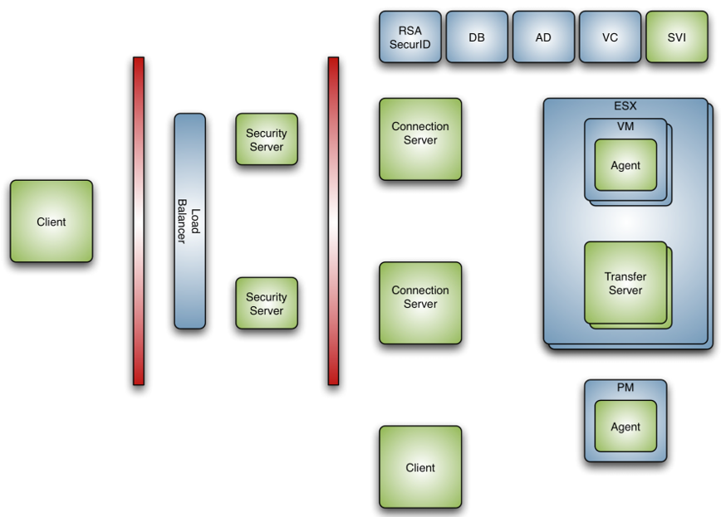

Prototype & evaluation
In the evaluation, we will set up a prototype system to prove the design concept. The prototype demonstrates that client can connect to floating desktop cross cloud rightly; and DM instance can scale cross cloud efficient. However, it also indicates docker swarm load balancer becomes the bottleneck when the scale is large.

we would like to see whether the system scales flexibly and is able to serve large number of concurrent requests effectively. We simulate large number of VDI clients, each sending requests to desktop manager to query and connect desktop concurrently. The client number changes from 1 to 128; The containers which hosts the desktop manager changes from 1 to 32.
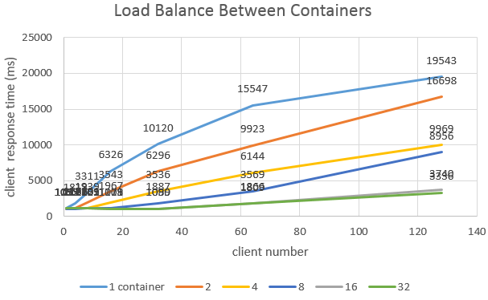
The above picture shows how client response time drops when scale up the containers. Take the data when client number is 128 as an example, when containers scale from 1 to 16, client response time drops dramatically, from 19,543ms to 3,740ms. However, when containers scale from 16 to 32, the drop is quiet minor, from 3740ms to 3336ms. This reason behind, perhaps, is when container number gets bigger, the bottleneck shifts from container to master. Therefore, we claim that the system scales up well when container number is no bigger than 16. After that, the load balancer becomes the bottleneck, so that increase the containers has little impact on client response time. The result suggests to solve the single node load balancer bottleneck issue if we plan to put the system into real use which need to serve large scale concurrency access. We leave this topic as future work.
Demo Migrate several service on the same VM from one cloud to another. Count the time spend in one migration.

Conclusion
总结本文主要做了那些工作，有哪些贡献

Future work
docker swarm overlay network在cross cloud的部署中存在很多的连通性和性能问题。这些问题如何克服？

REFERENCES
- VMware Instant Clone Technology for Just-In-Time Desktop Delivery in Horizon 7 Enterprise Edition http://blogs.vmware.com/euc/2016/02/horizon-7-view-instant-clone-technology-linked-clone-just-in-time-desktop.html
- 6 trends that will shape cloud computing in 2017: http://www.cio.com/article/3137946/cloud-computing/6-trends-that-will-shape-cloud-computing-in-2017.html
- Microservices https://en.wikipedia.org/wiki/Microservices

- Pattern: Monolithic Architecture http://microservices.io/patterns/monolithic.html

- Fallacies of distributed computing https://en.wikipedia.org/wiki/Fallacies_of_distributed_computing

